# **CTF Challenge: DNS Security Assessment Using DNSViz**



# **1. Introduction**

DNSViz is a tool designed to analyze the configuration of DNS records and provide detailed visualizations and reports. This challenge will introduce you to using DNSViz to assess the DNS security of a specific domain.

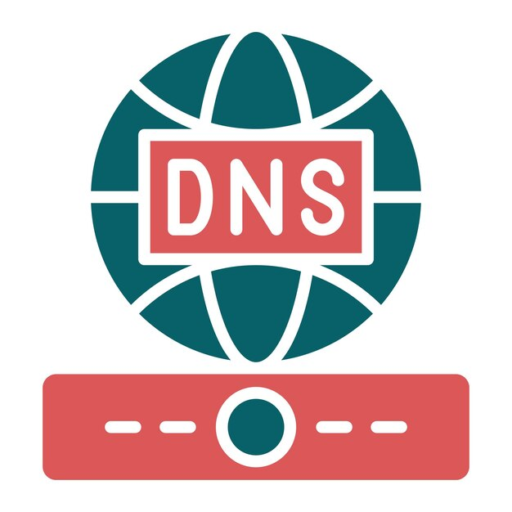

# **2. Tools and Requirements**

Access to the internet and search for DNSViz

# **3. Scenario**

Suppose, You are a network administrator responsible for ensuring the security and proper configuration of your organization's DNS records. Your task is to use DNSViz to evaluate the DNS setup of a critical domain and identify one specific issue that needs to be addressed.



# **4. Process to Follow while Performing CTF**

1. Go to CryptCheck: [**https://dnsviz.net/**](https://dnsviz.net/)

2. Enter the URL [**www.fortinet.com**](http://www.fortinet.com)in the search bar and start the performance test.

3. Click on the server option and solve the CTF.

# **5. Let’s Begin the Challenge**

**Question**

**Flag 1: Does ns2.fortinet.com have A records, and what is its IP address?**

*Answer: Yes, 96.45.36.48*

**Flag 2: Does ns3.fortinet.com have AAAA records?**

*Answer: No*

**Flag 3: What is the IP address of Authoritative IPs A records of ns4.fortinet.com?**

*Answer: 154.52.16.79*

**Hint:**

